Kelsey Frey

English 1106

Nicole Williams

1 March 2010

Proceed with caution: A bumpy yet enlightening journey aboard the Blacksburg Transit.

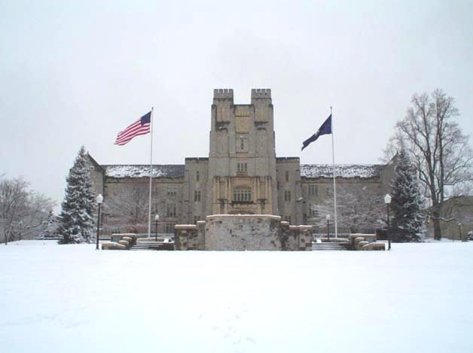Well, one thing is definitely for sure; it will snow. The bus may be late, you may be standing outside for several minutes waiting, you will probably be hungry, cold, and tired, but without fail, it will be snowing. Welcome to one of the most dramatic, cold winters of Blacksburg, Virginia. And, as I wait for the bus and snow seems to be coming from every direction, up down, right, and left, I contemplate which is worse: standing outside in the freezing cold, blustering weather or aboard a crowded, noisy bus. Ultimately, I know the warmth of the bus and the comfort of a roof over my head out competes this disastrous weather. But even so, as I stand at the bus stop in front of Burruss Hall looking towards the sky, and as snow begins to gently cling to the top of the roof, and as trees seem to slump with the weight of the never ceasing snow, and as large crystal snowflakes land lightly on the tips of my outstretched mitten-covered fingertips, I begin to recognize beauty in each flake. The beauty lies within the uniqueness and distinctness of each snowflake. When I take the time to stand in the moment, I begin to notice the eloquence and exceptionality of each flake, and despite the uncomfortable wind and blood chilling weather, I notice the delicate and exactness of its design; a singular beauty. In spite of myself, my anger seems to dissipate and is replaced with, perhaps enlightenment, or in any case, one of my first observations and connections with my site. I am a snowflake, unique in my design, distinct, and unlike anyone else. We are all snowflakes. Aboard the bus, we are a blanket of white snow, blending together, fallen from the heavens, yet we are each 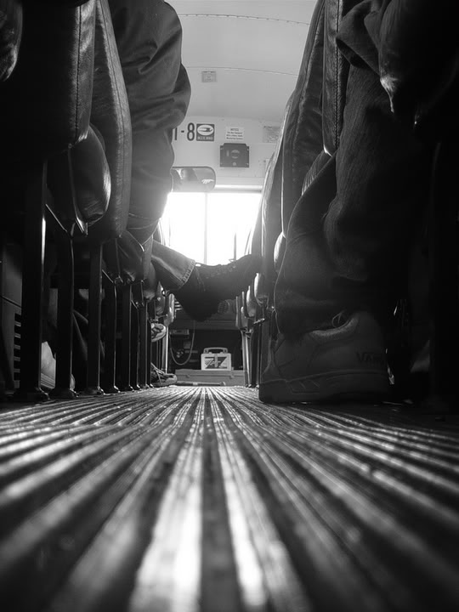rare in our design, one of a kind. So my journey on this bus is not so much about my final destination as it is about examining individual cultures, lifestyles, people and extinguishing my previous biases in hopes to have a better understanding of the distinct and diverse population of Virginia Tech.

As this, what I feel, momentous connection passes through my mind, I see Tom’s Creek B bus rounding the corner of the drillfield. In the distance, I see it stop with a loud creak to allow a small cluster of people with scarves pulled tightly around faces and necks walk swiftly across the street; it is as though wind and snow are pushing them across the snow covered, slippery road with such force that they barely have any say in which direction they will walk. It is with great happiness and relief that the bus eventually pulls up to the bus stop and relinquishing its giant, powerful doors warmth escapes and its hands grab me firmly and securely pulling me towards the opening of the bus. I clumsily find my Hokie passport needed for admittance, and painfully trying to move frozen limbs, I climb aboard the bus. Reaching out for the railing, I can feel the cool metal even through my mittens causing an uncontrollable shiver throughout my body. Shaking slightly, I hold out my passport for the driver who seems undisturbed by the bitterly cold air. Resembling an Eskimo of sorts, he is dressed in multiple layers, the top most, a thick coat, with white fur around the edges of the hood, a thick brown belt is just visible below his thick wool sweater; he also appears to be dressed in plain khaki cargo pants containing randomly sized pockets up the sides. His shoes are, perhaps, his warmest accessory; a pair of thick, brown boots laced tightly to mid-calf. Welcomed aboard and making eye contact for no more than half a second, I recognize tiredness of a long day’s work in his dark brown eyes. Short, choppy messy hair revealing slight hat hair gives way to long sideburns and a week or so old beard. Only a glimpse of the front dashboard is visible, but I am able to make out a variety of gadgets and technical instruments as the driver reaches out with dry and cracked knuckles to shut the doors in order to capture and keep the heat within the bus. Walking passed the driver’s oversized seat and under the “stop requested” sign, I look upon a sea of people, seats, and reflections. Night has fallen and the windows acting as pale reflections, I see myself walking from pane to pane. Surprised slightly by the roughness and tiredness of my appearance, I quickly turn my gaze to an empty seat positioned thankfully in the back corner secluded from the crowd. Unsocial and slightly awkward by nature, I prefer this opportunity to observe and learn from my peers around me. Upon sitting on the rough, brown seat of the bus and just beginning to feel slightly warmer, I am immediately drawn to a cluster of chattering girls also unbothered by the cold weather. Sitting in a triangle shaped pattern; two in the back and one in the front, they chat about a recent test. Upon further inspection, it seems to be a dreaded economics test. One girl sits Indian style facing her friends behind her. She has pale, porcelain skin and the lightest of blonde hair to match with 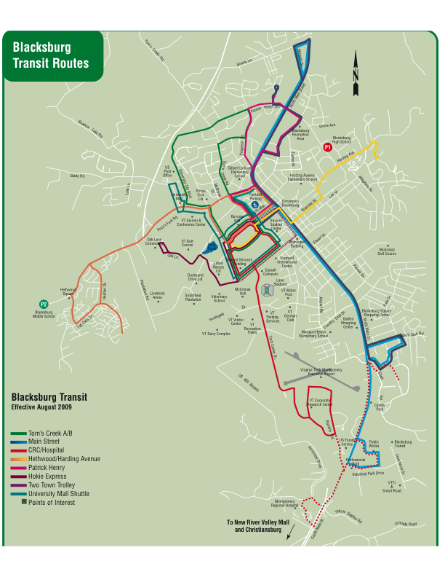freckles sprinkled across her nose and cheeks twittering away with ruby red fingernails upon her iPhone as a large silver peace sign shaped ring swings carelessly around on her index finger, and from what I can surmount, she repeatedly checks for her mid-term grade. And within every 30 seconds or the time it takes to refresh her screen, she looks up to her friends revealing a grimace and groan displaying her frustration and the anticipation of not 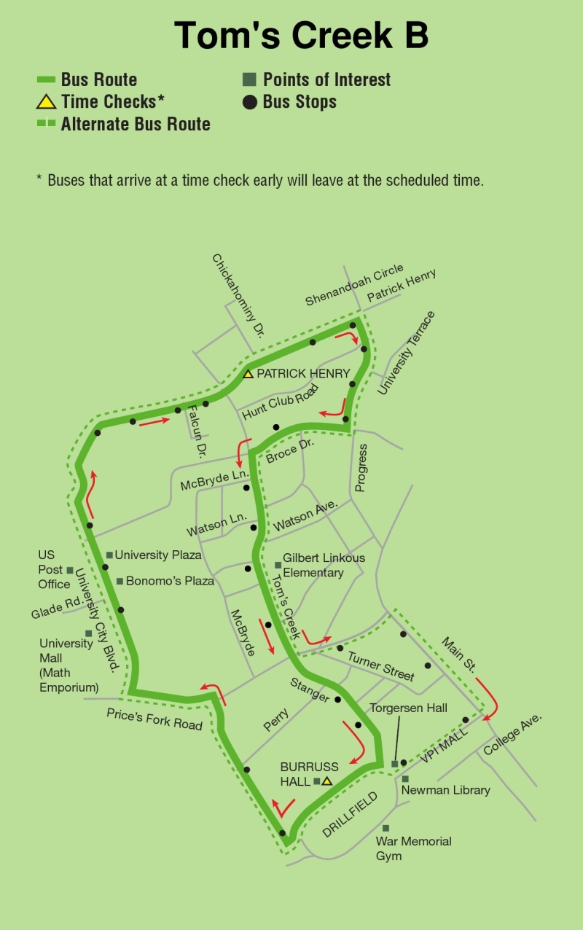knowing her grade. Her two friends, slightly calmer, are slouched back in their seats, laughing, not unkindly at her distress. The girl closest to the window tucks a long strand of silky, straight hair behind her ear revealing an array of earnings: one hoop, and two studs traveling up from her earlobe. She wears a pink Virginia Tech sweatshirt and rolls piercing blue eyes slightly at the girl’s anguish and reminds her of all the time they spent studying and that worrying is simply a waste of energy. Headphones seem to be dangling from beneath her sweatshirt, and she continues to tap her fingers across the top of her book bag in time to the music still tinkling away from her iPod. The tiniest of the three and the darkest with sun-kissed skin, perhaps Hispanic, speaks with a slight accent beneath large smoky, almond eyes and long, shiny black hair. She waves her hands dramatically in frustration and exuberance declaring a new subject as several bangles and bracelets slide noisily back and forth across her forearm.

Taking my eyes off the girls, I gaze outside and see morphed trees and buildings as we whip across the drill field only stopping once to allow pedestrians to cross. Beginning to feel almost cozy within in the warmth of the bus, I relax slightly, loosening the thick scarf around my neck. Making our first stop just before the stoplight, another three girls board the bus wearing similar clothes and talking quickly and enthusiastically in another language. They all seem to find comfort in lounge pants in a variety of patterns and even one with a display kitty cats as well as thick boots and oversized black coats. Despite my inability to understand what they are specifically talking about, I am able to recognize body language and in between their laughter, I notice the tallest of the three girls clutching her arms firmly across her body in an universal sign of coldness. They find seats near the front of the bus near an older looking student, a seasoned veteran of the bus system. A messenger bag is placed neatly in his lap. He sits calmly with fingers clasped gently atop his bag. Long dirty blonde hair sweeps slightly on to his long forehead just before he eyes, which are easily his best quality. Translucent, almost watering green eyes stare forward looking out onto another world, unforeseen by the rest of us. A small pocket on his chest houses an assortment of pens, and the plaid button up shirt tucked tightly into a pair dress khakis separated by a black leather belt with a silver square clasp.

As the bus takes a right at a stoplight, gathering speed around the corner, my stop is just a few blocks away, the dreaded math emporium. Beating me to it, a boy two seats in front of me, tentatively pulls the cord above him to signal for a stop. Dressed in skin tight, black skinny jeans that reveal a portion of his polka-dot boxers and an equally skin-tight black t-shirt promoting some unknown, perhaps, indie band with dark brown, slightly wavy hair that swishes and flips back with the wind has perfected the alternative, “rocker” look. While previously slouched back in his seat, one leg resting lightly across the other, a pencil poised in hand while a sketch pad sat in his lap drawing animatedly; He has now replaced his sketchpad back into his book bag and has begun lightly tapping his vans together. I perceived such passion and enjoyment while he had drawn, rushing with each fluid movement of his pencil, I recognized a certain eagerness to reveal and create an image that reflected his thoughts, feelings, and emotions. The bus makes an abrupt stop, breaks screeching loudly, I fall forward slightly in my seat holding tightly to my book bag. Fixing up my scarf and preparing myself mentally for the raging weather outside, I stand up slowly and cautiously, once more catching my reflections in the windows and passed the chattering girls, I find myself getting off the bus just behind the boy in the dark black jeans. I land lightly onto the snow-covered sidewalk and make way towards the busy street and on towards the math emporium.

The further the bus traveled and the longer I observed; I began to recognize more and more commonality between all of the passengers aboard the bus. But with that being said, I also recognize a uniqueness and distinctness in every individual as well. We may not speak the same language, wear the same clothes, or laugh at the same jokes, we have boarded the bus at the same time and for the same moment, and for no other reason, that unites us. And as I noticed the girl shaking slightly from the cold and the blonde haired girl anxiously awaiting her grade, I immediately am able to recognize and relate with all of their feelings and understand the universal signals of their language whether it be body language or facial expressions; our thoughts, fears, and perhaps ambitions are not so different after all. Looking out, I can see a kindred spirit, a perfectionist, a dreamer, a tired soul, a hopeless romantic, a “rock star”, and through thick and thin, bright and dull, round and almond, brown, green, and blue eyes I see a certain glint, a certain sparkle, a snowflake, if you will, gleaming silently but powerfully through all of their eyes making them truly unique and beautiful.



and leaning forward, she consoles her friend tapping her gently on the shoulder as several thick strands of her hair fall into her face. I can just make out a chunky gold necklace swaying from her neck against the edge of the seat and her chest.

from her neck standin

groaning systematically every five.

Seats positioned in a variety of directions and the glare of vibrant lights immediately

Our commonality, just as the snow, we blanket a common area for the same purpose, yet, we are unique and extremely different from one another, and with these observations, I intend to bring a perspective to the many cultural backgrounds and lifestyles into a social context.

no two are similar and finding my way back from this discovery, I now see the snow in a different light. All together is creates a white mass, a blanket of harmonizing beauty, and alone it is a certain type of uniquness and distinctiveness of its own.

the snowflakes are large enough and, one can see the delicate curves and the eloquence of its design.

440 SHANKS

excerpt

can truly begin to understand and appreciate the beauty of its eloquent and profound design. So as my anger and frusterated with the down pore snow begins to dissapate, I make one of my first discoveries and connections with my site. Just as each snowflake

And while this is not perhaps the most profound revelation, it is one of my first observations made at my site.